Grade 4 worksheet
Chapter 01: Knowing your computer

Name: _____________ Date: _____________ section: ______________

Fill it:
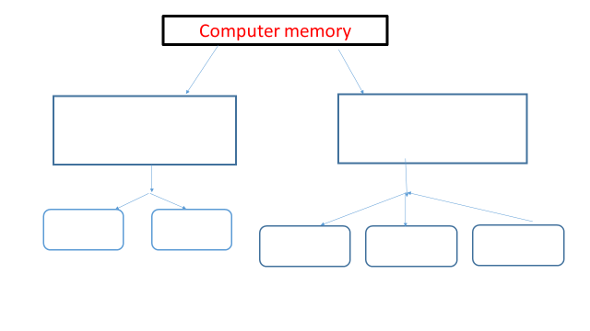
Sort which are the input and output devices of the computer and write their names.

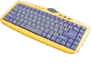  (Input/ Output Device) | 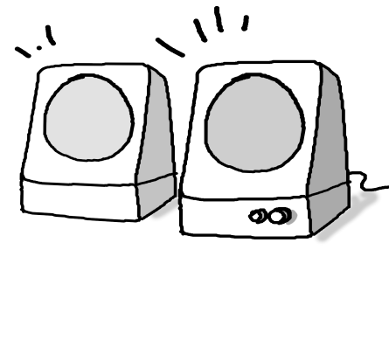  (Input/ Output Device)
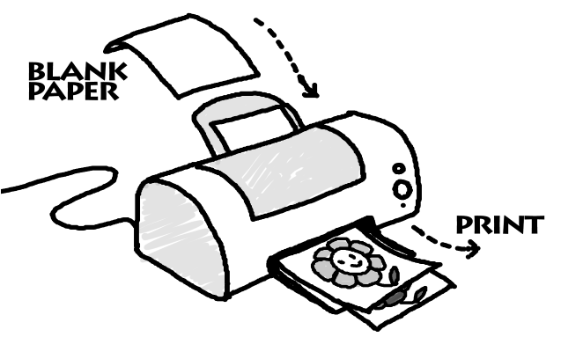  (Input/ Output Device) | 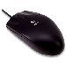  (Input/ Output Device)

