Let's Go to the Zoo!
Name: ______________________ Class: ________ Date: ____________
Look at the picture. Use the word bank to write 8 to 10 sentences in your copy.
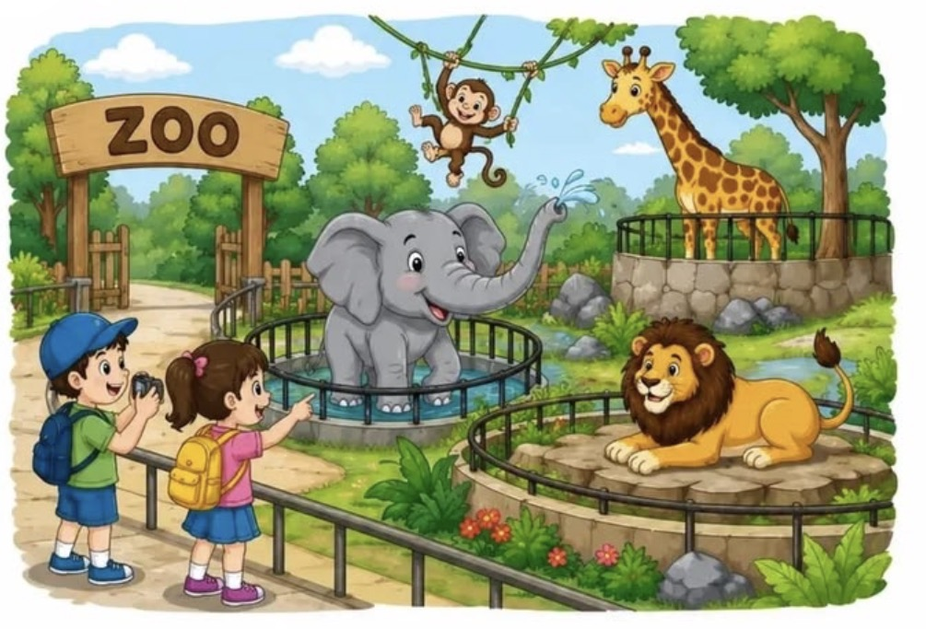
Word Bank
Animals  elephant, monkey, giraffe, lion | People & Things  boy, girl, camera, backpack, cap, vines, water | Places  zoo, gate, fence, pond, path, trees, rocks, grass
Action Words  see, look, point, take a photo, hang, swing, splash, sit, smile, walk | Describing Words  big, small, tall, long, grey, brown, yellow, happy, funny, brave | Sentence Starters  I can see ... | There is a ... | The ___ is ... | The children are ... | I like the ...
Remember: start with a capital letter and end with a full stop.

