Grade VII
Chapter:3Computational Thinking, Programming Languages
Home practice task

- Create a program in python that asks the user to enter 3 numbers. Firstly add these three numbers, then divide the sum by 3. This will take out the average of those three numbers. Display the sum and average.
- Create a program in python that declares two integer variables, assigns values 20 and 30 to those. Then multiply those numbers. Display the product of these two numbers
- Create a program in python that asks the user if his or her age is greater than 12 or not. If age is greater than 12 then display “You can play in the football tournament” otherwise display “You cannot play in the football tournament”

Use the online python compiler for these.
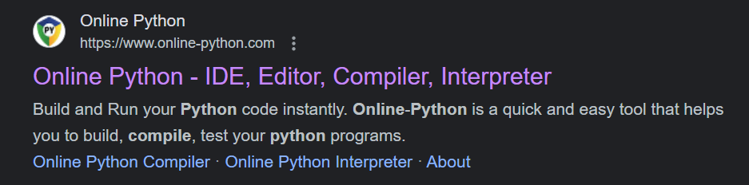

Send the screenshots of your program outputs to the following email address with your names, class and section mentioned clearly in email subject
digitalcubiclepk@gmail.com

